Documenting an Adverse Reaction in the Lab
This guide follows the workflow that is outlined in the Blood Specimen Collection policy regarding adverse Lab Events. Click here to review the policy on SharePoint for more detailed information regarding blood specimen collection.
The events that should be documented in Epic include but are not limited to:
- Syncope or near-syncope
- Patient or phlebotomist injury
- The inability to collect sample within 4 pokes (2 pokes per phlebotomist) OR if a third person is required to complete the draw
  - If consultation with a clinician is necessary to go beyond 6 pokes total
- Inability to complete test collection for any other reason

Adverse Event Checklist:
- Start and sign a documentation only encounter in Epic
  - From Order Review, open a documentation only encounter.
  - Document the adverse event and any follow up actions taken.
  - Sign the encounter.
- Add a Specialty Comment in the patient’s chart in Epic for difficult draws
  - Find the Blue Sticky Note in the Storyboard.
  - Type the comment.
    - Reasons to create a specialty comment in a patient’s chart:
      - Patient is difficult to draw (required more than 4 pokes to draw)
      - Has experienced syncope or near-syncope
      - Patient injury
  - Click the X to close it and save the comment.
- Initiate an Alert (Pop-up) in Orchard in the patient’s chart for difficult draws
  - Open the patient’s chart in Orchard.
  - In Patient Info tab, find the Alerts field.
  - Add the same verbiage from the Specialty Comment in Epic.
  - Click Save Patient.
- Connect with Supervisor and start an RL Datix ticket
  - Go to SharePoint Home page
  - Click the Feedback/Safety Event Reporting – RL Datix link in the WHA Links list.
  - Fill out the form. This can be completed by the Lab Assistant or in conjunction with their supervisor.

Starting a Documentation Only Encounter
As the Lab Assistant is drawing up the sample, it can be helpful to have the patient’s Show Orders activity open. This protects other patients’ information and makes it easy to see what should be drawn. This is the screen the tip sheet will start on. Ensure you have the correct patient’s chart open when you pull the patient back and verify their labels and labs with them.
- From Order Review, open a new encounter either from the Hyperspace Toolbar or the Epic activity menu.
  - Hyperspace Toolbar – click the Encounter button.
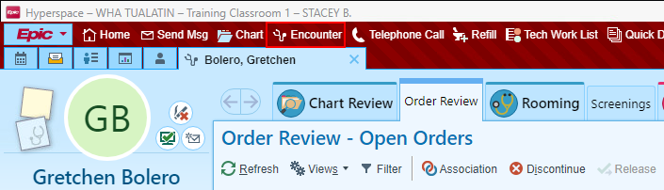
  - Epic activity menu – click the Epic menu button, go to Patient Care, then click Encounter.
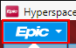 > 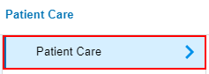 > 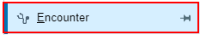
    - The push pin can be clicked to save this either to the Hyperspace toolbar if it’s not already there, or to the pinned items in the Epic menu.
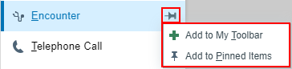
- A Search for a Patient box will open.
  - If you are already in the patient’s chart, in the middle of the box will be the patient’s name and MRN in a button. This helps ensure it is the correct patient’s chart to document in.
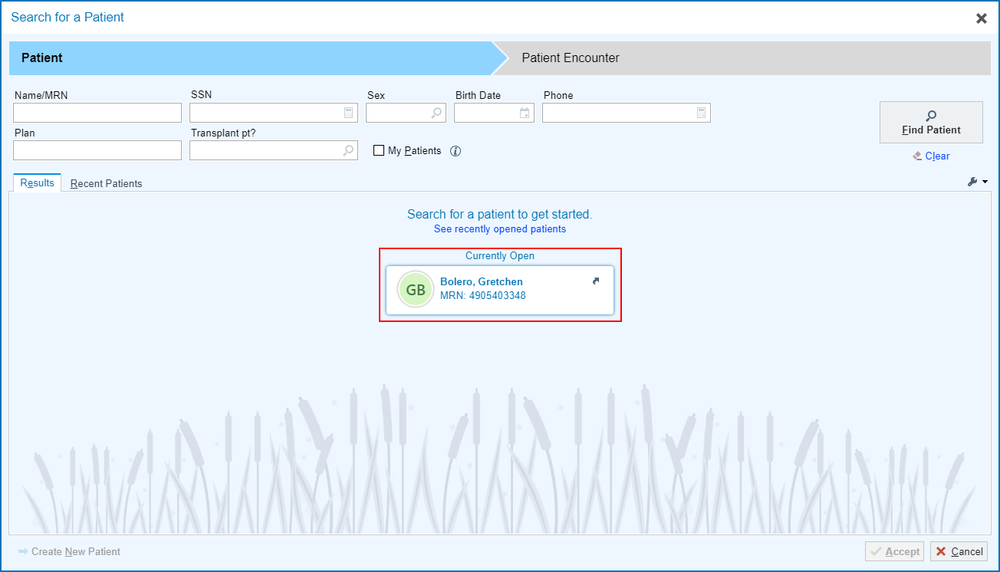
- Once the patient is selected, Epic will prompt the user to open either an existing encounter or create a new one. Click Create an Encounter.
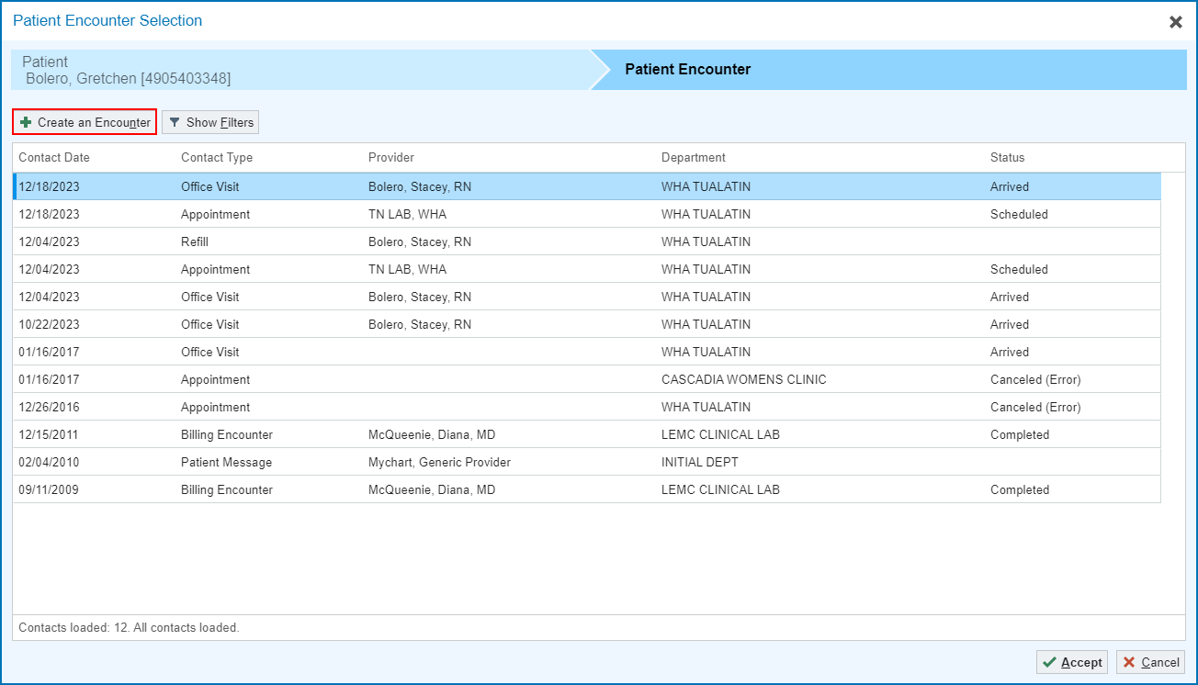
- Fill in the encounter information.
  - Date: Ensure this is the date the event occurred
  - Type: Documentation
  - Provider: this will likely be the provider who ordered the labs, if they are in clinic the day the event occurs.
    - If the ordering provider is not in clinic, use the on-call provider.
    - If the on-call provider is not in clinic, utilize the second call provider.
  - Department: the department (clinic name) the event occurred in
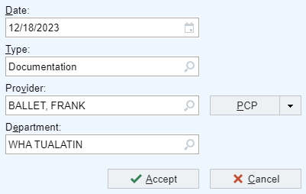
- Click Accept.
- A documentation encounter will open.
- Fill in the Reason for Documentation.
  - Reason: Other (See Comments)
    - Comment: Blood Draw Related Incident
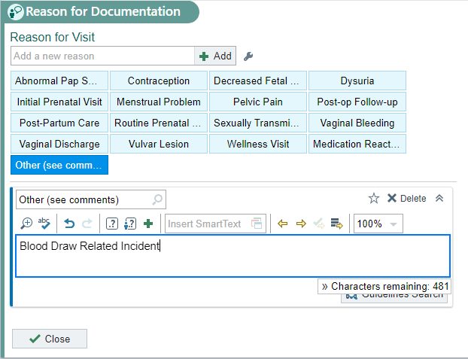
- In a blank Note document the event that happened and any follow up care and recovery for the patient.
*Note: This does not need to be overly detailed, but rather a quick recount of the events that happened. Further details can be provided in the RL Datix Ticket the Lab Assistant will start.*
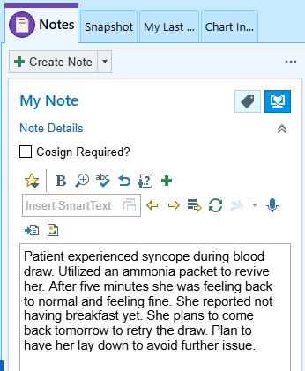
- Click Sign Encounter. 

Adding and Viewing Specialty Comments
Specialty Comments are comments that can be updated and viewed by anyone in the OBGYN specialty. To view and change Specialty Comments in the Storyboard open the patient’s chart review or visit encounter.

Adding a Specialty Comment from the Storyboard
- Click the Blue Sticky Note at the top of the Storyboard to open it.
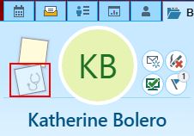
- If this is your first time opening the Blue Sticky Note, click the Pushpin to pin it. This ensures it will automatically open when you open a patient’s chart and comments are present. It should be vertical after clicking it.
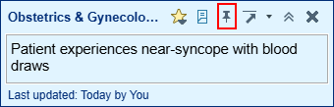
- Add and/or change comments in the box.
- Click the black X to close the box.
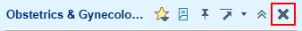
Notice the icon now has lines visible to indicate a note is present.
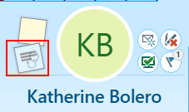
- Back in the Schedule Workspace, the Specialty Comment is now visible in the Preview Pane.

Adding a Specialty Comment from the Schedule Workspace
- From the Schedule Workspace, locate the Preview Pane.
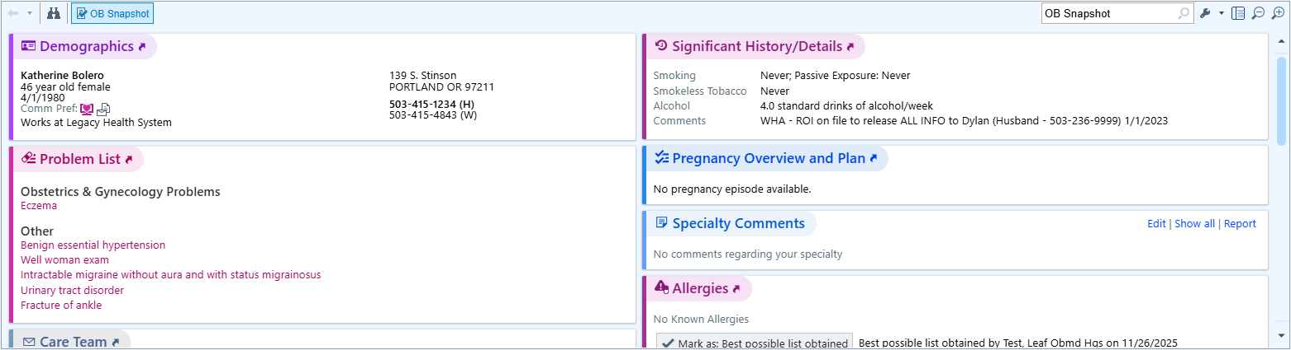
- To add and/or change Specialty Comments click the Edit hyperlink.
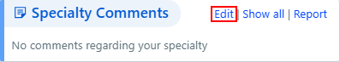
- Make changes, then click Accept.
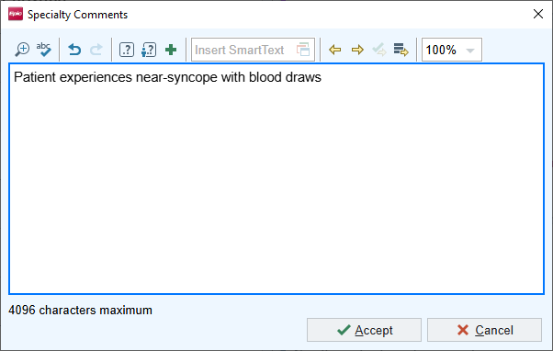

Viewing Specialty Comments in Epic
There are three ways to view these comments (Preview Pane, Storyboard, Schedule Column) and two main places to update them (Preview Pane and Storyboard).
A column can be added to the schedule to view Specialty Comments as well.
- Navigate to the Multi-Provider schedule.
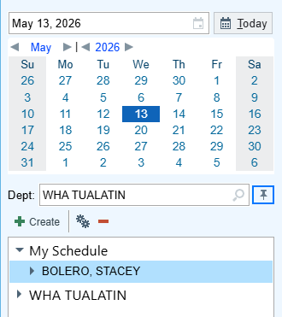
- Single click your schedule folder to highlight it then click the Gears.
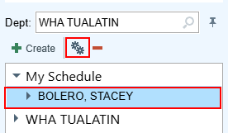
- In the Search box type: specialty comments and press enter.
- Single click the first option to highlight it.
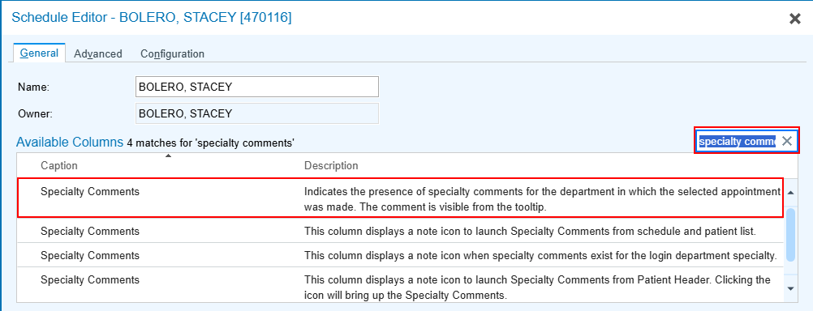
- Click
- In the Selected Columns section, find the newly added column at the bottom of the list and use the arrows to adjust its position in the column lineup.
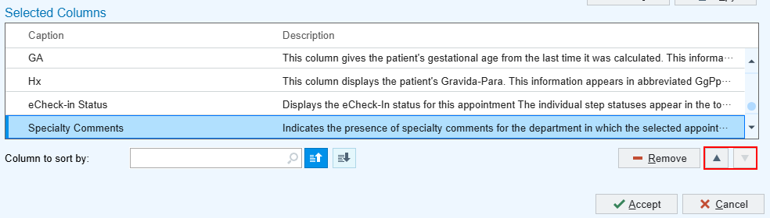
- Click
- Hover on the icon in the schedule to view the Specialty Comment.
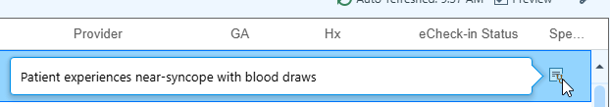

Adding and Viewing Alerts (Pop-ups) in Orchard

- Open the Find a Patient workspace.
- Search for the patient.
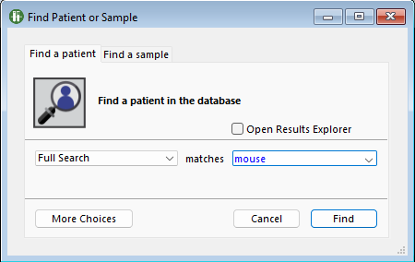
- Select your patient from the search results and click Accept.
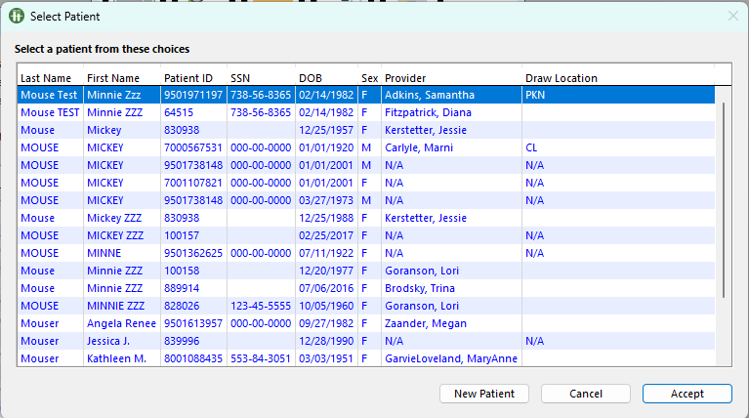

- The patient’s chart will open to the Patient Info tab.
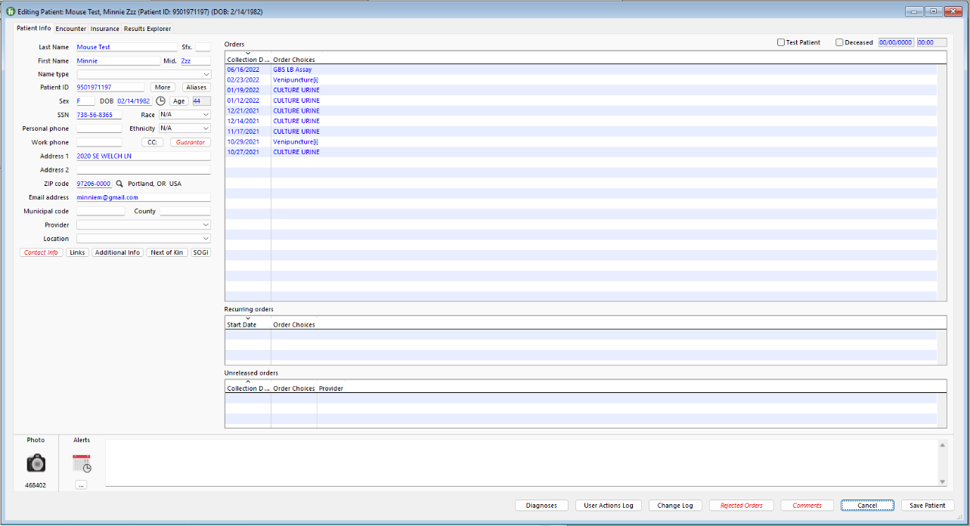
- At the bottom of the window find the Calendar button. 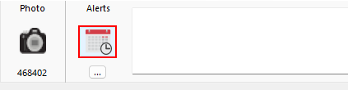
  - This will pull in the date and time into the Alerts box.
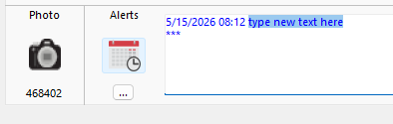
- Document the event with the same information that was documented in the Specialty Comments box. At the end of the comment type your initials.
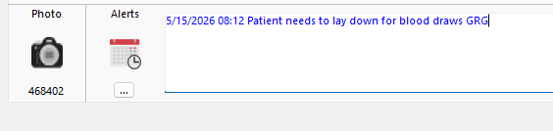
- Click the Save Patient button at the bottom right of the screen.
- Select ordering provider and click Accept.
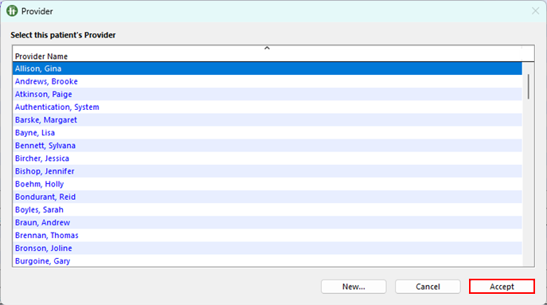

When the patient’s chart is opened, a pop up will now appear with the alert for the next phlebotomist.
